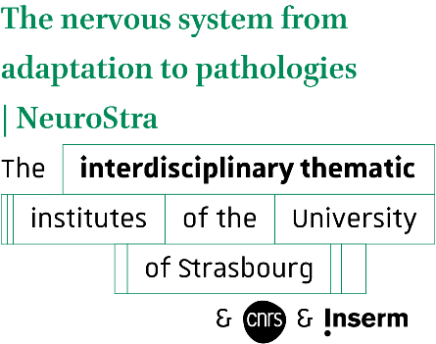
Junior Group Leader position

ITI NeuroStra, Strasbourg, France

Application form 2026
Mental health
Neuroepigenetics
Nociception and Pain

Your application must be sent in a single pdf file to nexon@unistra.fr before the end of
December 19th, 2025.

- General information
LAST NAME First name
Institutional email address
Personal email address (not mandatory)
Gender
Nationality
Birthdate
Parental leave
Present position and institutional affiliation
(including address)
Which of these themes will your project address? (Multiple themes possible)
- Mental health
- Neuroepigenetics
- Nociception and Pain
Which NeuroStra team(s) would your project align with?
(note: initiating contact with the targeted team(s) is strongly encouraged)
How do you see your career progression within NeuroStra?

- PhD
Laboratory / Team (names, address)
Thesis title
Thesis funding
Date of defence (format dd/mm/yyyy)

- Post-Doctorate
Laboratory / Team (names, address)
Project title
Funding
Number of invited conferences

Please replicate the chart for each additional postdoctoral position

- Publications
Complete list of publications issued from your PhD work
Complete list of publications issued from your postdoctoral work
Selection of three articles that you consider your most significant scientific contribution to the field.
Indicate the reference of the article and briefly explain why you consider it significant.
Article #1
Article #2
Article #3

- Complete CV

- Description of your previous achievements
1-2 pages maximum. Typo: Calibri 11 or equivalent.

- Your research project within NeuroStra
A research project proposal (2-3 pages) detailing your planned investigation on one or several of the following themes: "Mental Health”, "Neuroepigenetics”, and "Nociception and pain”. Your project should align with one or several NeuroStra teams. Typo: Calibri 11 or equivalent.

- Recommendation letters
Along with this form, please include two letters of recommendation.

